16.265 Logic Design Spring 2009
Student Logic Number | 100
Name | John Doe
E-mail address (print) | john_doe@uml.student.edu
Experiment Number | 2
Date | 03-20-2009

For grader use
No CD/disk or  No schematic file on CD/disk | 5 points deduction
Schematic diagram on CD/disk is different from the one in the report. (Need to re-submit the schematic diagram in the report or will be graded based on a maximum of 50 points. | 5 points deduction
Cannot open file
File is not readable

Date student is notified to re-submit a schematic file by e-mail
Date schematic file received

Report will be graded based on a maximum of 50 (out of 100 points) if a schematic diagram is not received within three calendar days of notification or the re-submitted schematic file still cannot be opened or is not readable.

Grade: ___________
Experiment 2 Design of a Code Converter

1. Input and output code assignment

Input code: Reflected code (from p.20 of text)

Output code: (6,3,1,1) weighted code

2. Design Procedures

Truth table for code converter (If ABCD is an invalid input code,

write “invalid” in the column for decimal digits.)
Decimal  digit for binary code | Decimal equivalent of ABCD | Inputs  A B C D | Outputs  V W X Y Z
0 | 0 | 0 0 0 0 | 1 0 0 0 0
1 | 1 | 0 0 0 1 | 1 0 0 0 1
3 | 2 | 0 0 1 0 | 1 0 1 0 0
2 | 3 | 0 0 1 1 | 1 0 0 1 1
Invalid | 4 | 0 1 0 0 | 0 d d d d
Invalid | 5 | 0 1 0 1 | 0 d d d d
4 | 6 | 0 1 1 0 | 1 0 1 0 1
Invalid | 7 | 0 1 1 1 | 0 d d d d
9 | 8 | 1 0 0 0 | 1 1 1 0 0
8 | 9 | 1 0 0 1 | 1 1 0 1 1
6 | 10 | 1 0 1 0 | 1 1 0 0 0
7 | 11 | 1 0 1 1 | 1 1 0 0 1
Invalid | 12 | 1 1 0 0 | 0 d d d d
Invalid | 13 | 1 1 0 1 | 0 d d d d
5 | 14 | 1 1 1 0 | 1 0 1 1 1
Invalid | 15 | 1 1 1 1 | 0 d d d d

Express V, W, X, Y, Z in minterm list form

V = Σ m(0, 1, 2, 3, 6, 8, 9, 10, 11, 14)
W = Σ m(8, 9, 10, 11) + d(4, 5, 7, 12, 13, 15)
X = Σ m(2, 6, 8, 14) + d(4, 5, 7, 12, 13, 15)

Y = Σ m(3, 9, 14) + d(4, 5, 7, 12, 13, 15)
Z = Σ m(1, 3, 6, 9, 11, 14) + d(4, 5, 7, 12, 13, 15)

Design for V

K-map for V
00
01
10
11
00
01
10
11
CD
AB
1
1
1
1
1
1
1
1
1
1
0
0
0
0
0
0

Simplest SOP = B’ + CD’

00
01
10
11
00
01
10
11
CD
AB
0
0
0
0
0
0
1
1
1
1
1
1
1
1
1
1

Simplest POS = (B’ + C)(B’ + D’)

Realization and gate transformation for V

Minimize either the simplest SOP or the simplest POS obtained from the K-map to an expression with a minimum number of literals.

V = B’ + CD’

Draw the circuit for V with a minimum number of 2-input AND gates and 2-input OR gates using LogicWorks:
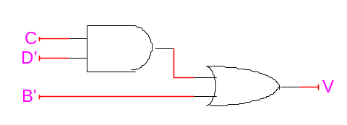

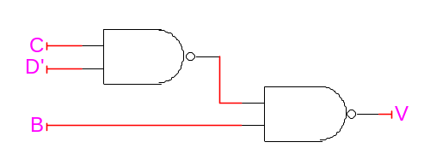
Draw the circuit for V with only NAND gates and/or NOR gates using LogicWorks:

Design for W

K-map for W

00
01
10
11
00
01
10
11
CD
AB
d
d
1
1
1
1
d
d
d
d
0
0
0
0
0
0

Simplest SOP = AB’

00
01
10
11
00
01
10
11
CD
AB
d
d
1
1
1
1
d
d
d
d
0
0
0
0
0
0

Simplest POS = AB’

Realization and gate transformation for W

Minimize either the simplest SOP or the simplest POS obtained from the K-map to an expression with a minimum number of literals.

W = AB’

Draw the circuit for W with a minimum number of 2-input AND gates and 2-input OR gates using LogicWorks:
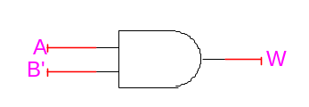

Draw the circuit for W with only NAND gates and/or NOR gates using LogicWorks:
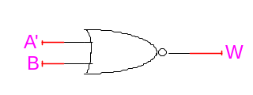

Design for X

K-map for X
00
01
10
11
00
01
10
11
CD
AB
d
d
0
0
0
1
d
d
d
d
1
1
0
1
0
0

Simplest SOP = B + A’CD’ + AC’D’

00
01
10
11
00
01
10
11
CD
AB
d
d
0
0
0
1
d
d
d
d
1
1
0
1
0
0

Simplest POS = D’(A + B + C)(A’ + B + C’)

Realization and gate transformation for X

Minimize either the simplest SOP or the simplest POS obtained from the K-map to an expression with a minimum number of literals.

X = B + A’CD’ + AC’D’ = B + D’(A’C + AC’)
Draw the circuit for W with a minimum number of 2-input AND gates and 2-input OR gates using LogicWorks:
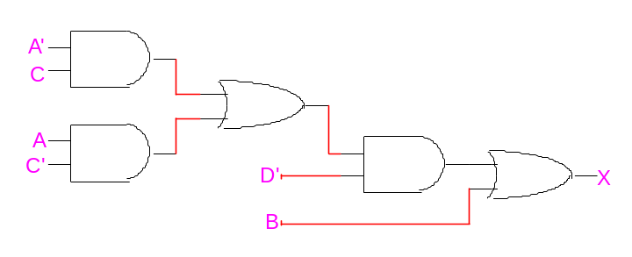

Draw the circuit for X with only NAND gates and/or NOR gates using LogicWorks:
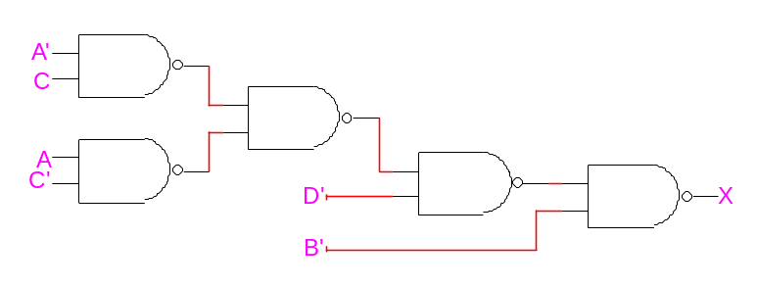

Design for Y

K-map for Y
00
01
10
11
00
01
10
11
CD
AB
d
d
1
0
0
0
d
d
d
d
0
1
0
0
1
0

Simplest SOP = AB + A’CD + AC’D

00
01
10
11
00
01
10
11
CD
AB
d
d
1
0
0
0
d
d
d
d
0
1
0
0
1
0

Simplest POS =

(A + C)(B + D)(A + B’)(A’ + C’ + D’)

Realization and gate transformation for Y

Minimize either the simplest SOP or the simplest POS obtained from the K-map to an expression with a minimum number of literals.

Y = AB + A’CD + AC’D = AB + D(A’C + AC’)

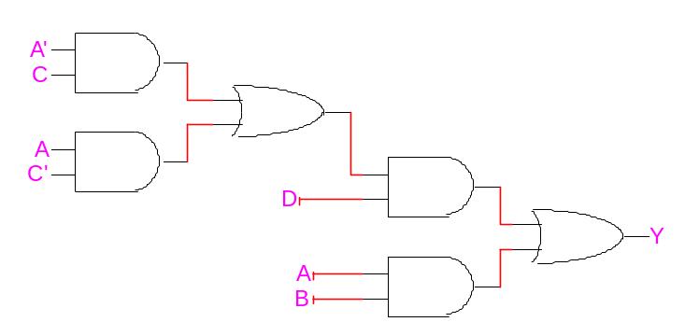
Draw the circuit for Y with a minimum number of 2-input AND gates and 2-input OR gates using LogicWorks:

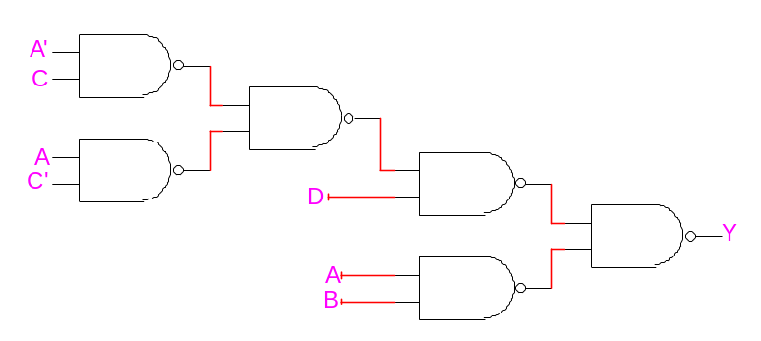
Draw the circuit for Y with only NAND gates and/or NOR gates using LogicWorks:

Design for Z

K-map for Z
00
01
10
11
00
01
10
11
CD
AB

d
d
0
0

Simplest SOP = B + D
1
d
d
1

1
d
d
1

0
1
1
0

00
01
10
11
00
01
10
11
CD
AB
d
d
1
0
1
0
d
d
d
d
1
1
1
0
1
0

Simplest POS = B + D

Realization and gate transformation for Z

Minimize either the simplest SOP or the simplest POS obtained from the K-map to an expression with a minimum number of literals.

Z = B + D

Draw the circuit for Z with a minimum number of 2-input AND gates and 2-input OR gates using LogicWorks:
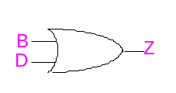

Draw the circuit for Z with only NAND gates and/or NOR gates using LogicWorks:
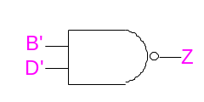

3. Schematic diagram for code converter

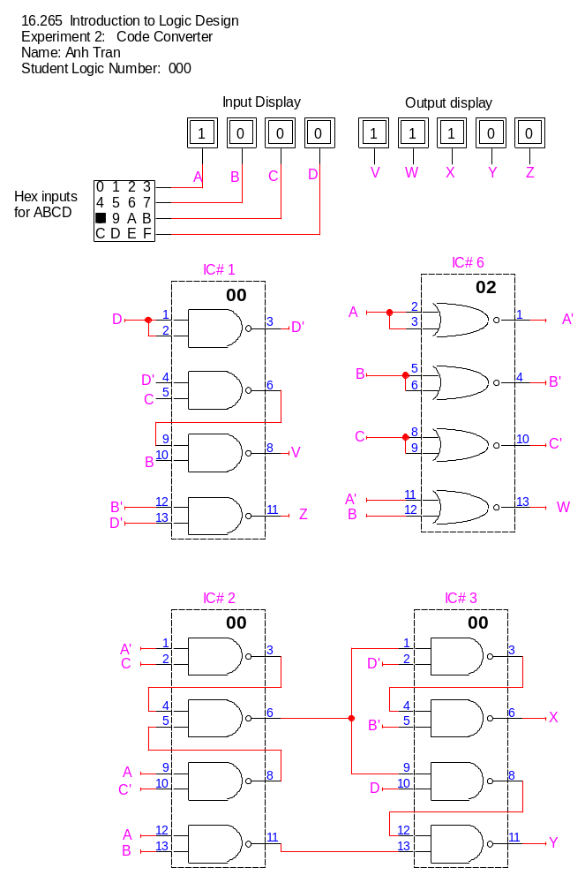

4. List of ICs and unused gates

IC number | Type number | Function | Unused gates
1 | 7400 | Quad 2-input NAND | 0
2 | 7400 | Quad 2-input NAND | 0
3 | 7400 | Quad 2-input NAND | 0
4 | 7400 | Quad 2-input NAND | 4 (IC not used)
5 | 7400 | Quad 2-input NAND | 4 (IC not used)
6 | 7402 | Quad 2-input NOR | 0
7 | 7402 | Quad 2-input NOR | 4 (IC not used)
8 | 7402 | Quad 2-input NOR | 4 (IC not used)

5 Simulation results

Table for simulation results
(Place a check mark in the column “Incorrect results” for each simulation value that is different from the value listed in the truth table in Section 2.)
Decimal  digit | Inputs | Simulation results |  | Incorrect results
Decimal  digit | A B C D | V | W X Y Z | V | W | X | Y | Z
0 | 0 0 0 0 | 1 | 0 0 0 0
1 | 0 0 0 1 | 1 | 0 0 0 1
2 | 0 0 1 1 | 1 | 0 0 1 1
3 | 0 0 1 0 | 1 | 0 1 0 0
4 | 0 1 1 0 | 1 | 0 1 0 1
5 | 1 1 1 0 | 1 | 0 1 1 1
6 | 1 0 1 0 | 1 | 1 0 0 0
7 | 1 0 1 1 | 1 | 1 0 0 1
8 | 1 0 0 1 | 1 | 1 0 1 1
9 | 1 0 0 0 | 1 | 1 1 0 0
Invalid input | 0 1 0 0 | 0 | 0 1 0 0 |  | N/A
Invalid input | 0 1 0 1 | 0 | 0 1 0 1
Invalid input | 0 1 1 1 | 0 | 0 1 1 1
Invalid input | 1 1 0 0 | 0 | 1 1 0 0
Invalid input | 1 1 0 1 | 0 | 1 1 0 1
Invalid input | 1 1 1 1 | 0 | 1 1 1 1

